Joint CQSE & NCTS Seminar

2024
Sep. 27, Friday

Time: Sep. 27, 14:20 ~ 16:20
Title: 量子計算的潛力與極限 --- 從理論的角度認識量子電腦的計算能力
Speaker: 鐘楷閔特聘研究員&副所長 (中央研究院 資訊科學研究所)
Place: Rm. 104, Chin-Pao Yang Lecture Hall, Department of Physics/CCMS, NTU
Online Link: https://nationaltaiwanuniversity-zbh.my.webex.com/nationaltaiwanuniversity-zbh.my/j.php?MTID=m7601bdfa496ccaf8aac2838aab8c25f2

Abstract:
在這場演講我們將從理論計算機科學(Theoretical Computer Scinece)的計算視角來看量子計算。 所謂的計算視角 (Computational Lens)，是透過計算和演算法的框架來探索世界各種現象。我們將從計算機科學的演算法、複雜度理論與密碼學的角度來談量子計算的潛力與極限，並與其他計算模型比較。 時間許可的話，我也會淺談一下我的研究。

Biography:
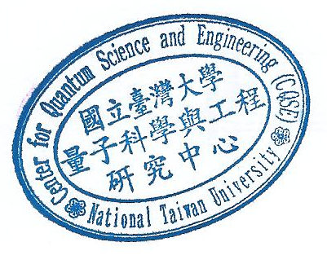
Kai-Min Chung received a bachelor''s degree from National Taiwan University in 2003, and a Ph.D. from Harvard University in 2011. His advisor was Salil Vadhan. After his Ph.D., he was a postdoctoral researcher at Cornell University for three years and supported by Simons postdoctoral fellowship in 2010-2012. He joined the Institute of Information Science, Academia Sinica as an assistant research fellow in Sept., 2013, and became an research fellow in Feb., 2020. His research interests lie in the field of cryptography and its interplay with complexity and quantum theory. He has published works in these fields at major conferences such as STOC, FOCS, CRYPTO, CCC, QIP, and TCC. His work on parallel repetition for interactive arguments received a best student paper award from Theory of Cryptography Conference in 2010. He has served on the program committees of major cryptography conferences such as CRYPTO, TCC, and Asiacrypt.

