Joint CQSE & NCTS Seminar

2024
Nov. 22, Friday

Time: Nov. 22, 14:30 ~ 15:30
Title: Hardware-Efficient Logical Quantum Error Correction using Bosonic Degrees-of-Freedom
Speaker: Dr. Matt Matheny (Research Science Manager, Amazon Web Services)
Place: NCTS Physics Lecture Hall, 4F, Chee-Chun Leung Cosmology Hall, NTU
Online Link: https://nationaltaiwanuniversity-zbh.my.webex.com/nationaltaiwanuniversity-zbh.my/j.php?MTID=m7601bdfa496ccaf8aac2838aab8c25f2

Abstract:
One of the first steps towards quantum computation is encoding an error-corrected logical qubit into a lattice of physical qubits. To correct both bit and phase errors across these physical qubits typically requires a lattice of 2 or more dimensions. In this talk, I will describe a recent experiment in superconducting circuits whereby only a linear lattice of harmonic oscillators is required to encode a logical qubit. This logical qubit takes advantage of two different quantum error correcting codes, an “inner” bosonic cat code to correct for bit flips, and an “outer” linear repetition code to correct for phase flips. I will present results both for the individual bosonic cat qubits and for the repetition code, with projections to next-generation systems.
Refs:
Putterman, Harald, et al. "Preserving phase coherence and linearity in cat qubits with exponential bit-flip suppression." arXiv preprint arXiv:2409.17556 (2024).
Putterman, Harald, et al. "Hardware-efficient quantum error correction using concatenated bosonic qubits." arXiv preprint arXiv:2409.13025 (2024).
Biography:
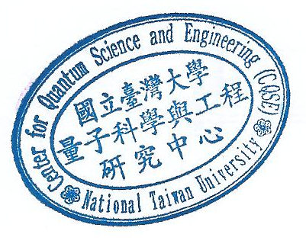
Matt Matheny helped found the Center for Quantum Computing at Amazon Web Services, where he is now a Research Science Manager. At AWS, he has been responsible for many of the team’s “firsts”, most notably as the manager in charge of the bosonic cat code architecture. Previously, he was Research Staff at Caltech where he performed research in information thermodynamics, optomechanics, and dynamical systems.

