Joint CQSE & NCTS Special Seminar

2025
July 9, Wednesday

Time: July 9, 14:30 ~ 15:30
Title: Constructing discrete time crystals with a response being any multiple of the driving period
Speaker: Prof. Tzu-Chieh Wei (Department of Physics and Astronomy, Stony Brook University)
Place: Rm. 104, Chin-Pao Yang Lecture Hall, Department of Physics/CCMS, NTU
Online Link: https://nationaltaiwanuniversity-zbh.my.webex.com/nationaltaiwanuniversity-zbh.my/j.php?MTID=m61c4f18de3538d1d61c9cceb155faebb

Abstract:
A time crystal is a phase of matter that spontaneously breaks time translation symmetry. As it cannot appear in equilibrium and continuous time setting, most proposals of time crystals employ periodic i.e., Floquet driving and the response of the system breaks discrete time translation to, e.g., a period twice the driving. Here, we propose a new Floquet time crystal model that responds in arbitrary multiples of the driving period. Such an n-tuple discrete time crystal is theoretically constructed by permuting spins in a disordered chain and is well suited for experiment implementations. Transitions between these time crystals with different periods give rise to a novel phase of matter that we call subspace-thermal discrete time crystals, where states within subspaces are fully thermalized at an early time. However, the whole system still robustly responds to the periodic driving sub-harmonically, with a period being the greatest common divisor of the original two periods. We develop a theoretical framework for the robustness of discrete time crystals from the perspective of the robust 2pi/n quasi-energy gap. Its robustness is rigorously proved if the system satisfies a certain condition where the mixing length, defined by the Hamming distance of the symmetry charges, does not exceed a global threshold. Our construction can be generalized to systems with higher spin magnitudes or qudits, as well as to higher spatial dimensions..
Biography:
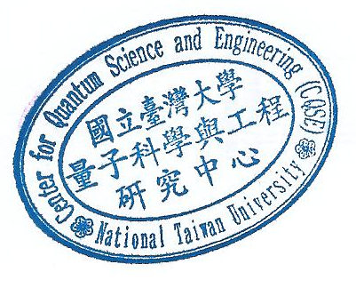
Tzu-Chieh Wei received his B.A. and M.Sc. in physics from National Taiwan University before the millennium. He earned his PhD degree in physics from the University of Illinois in 2004. Afterwards, he held postdoctoral and research associate positions at the University of Illinois, the University of Waterloo (in their Institute for Quantum Computing), and the University of British Columbia. In 2011, he joined the faculty of the C. N. Yang Institute and Department of Physics and Astronomy at Stony Brook University.

